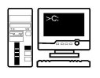

**VB Programming**

**Iteration – For Loops**

**Task**

Produce a program to work out the average of any number of sales figures that are entered by the user.

**Approach**

* The user is initially asked how many sales figures they want to enter.
* The program loops the specified number of times.
* Each time around the loop the program asks the user to enter the specified sales figures
* The latest sales figures are added to running total
* Once the user finishes entering, an average is produced and output

This is what the output should look like:

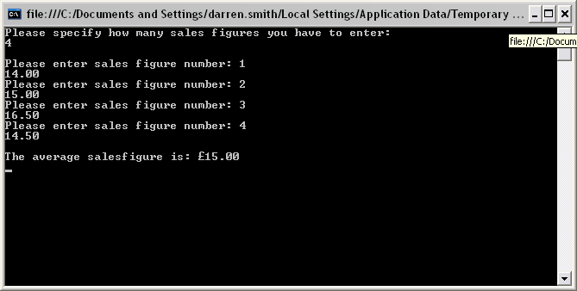

Extensions

* Format the average as a currency
* Output the highest sales figure
* Output the lowest sale figure